**Analyzing the Performance & Efficiency of Radisson Hotels using Data Visualization Techniques**

**Category**: Data analytics with Tableau

NM_ID: 6D8B683C2464CDC9C344EAD6E958568E

Team ID: **NM2023TMID09874**

Internship at: SmartInternz

|  |  |
| --- | --- |
| Team Lead | **AKILANAYAKI K** |
| Team Members | **DEVIKA V** |
| **DHAMU M** |
| **DHANESWARI D** |

**Email Id:** [**abiramyakila@gmail.com**](mailto:abiramyakila@gmail.com)

1. Introduction

1.1 Overview

The hotel industry is a vast and diverse sector that encompasses a wide range of businesses that provide lodging services to travellers and tourists. Radisson is a well-known hospitality brand that owns multiple five-star hotels across India. However, due to strategic moves from other competitors and ineffective decision-making in management, Radisson is losing its market share and revenue in the luxury/business hotels category. In response, the managing director of Radisson has tasked us with creating an analytics dashboard and story to provide insights for better decision making.

1.2 Purposes

This project report aims to provide a comprehensive analysis of the hotel industry, with a focus on the luxury/business hotels category. The report will also explore the challenges faced by Radisson and the importance of incorporating Business and Data Intelligence to regain their market share and revenue. The report will include a detailed description of the analytics dashboard and story that we created for Radisson, which will provide valuable insights for better decision-making. The report will also discuss the methodology used in developing the dashboard and story, including data sources, data cleaning, and data analysis techniques.

2. Problem Definition & Design Thinking

Generally, if the given data set was to be analyzed in the old-fashioned methods, such as using geometrical instruments to draw the graphs on a piece paper, using scales & graph papers to plot the variation of the data fields, etc. The problem is to identify the key performance indicators (KPIs) and metrics to analyze the performance and efficiency of Radisson Hotels, compare performance across different hotels, identify patterns and trends over time, and create forecasting models for future performance. The social impact of this analysis includes improving the safety of customers, ensuring guest satisfaction, and promoting hygiene in food.

2.1 Proposed Solution

The proposed solution is to develop an analytics dashboard and story that will provide Radisson Hotels with insights to make better business decisions. The analysis will identify key performance indicators (KPIs) and metrics to analyze the performance and efficiency of Radisson Hotels, compare performance across different hotels, identify patterns and trends over time, and create forecasting models for future performance. A literature survey will be conducted to review existing literature and studies related to hotel performance and efficiency, identify best practices and strategies, and explore any unique challenges or opportunities specific to Radisson Hotels.

2.2 Empathy Map

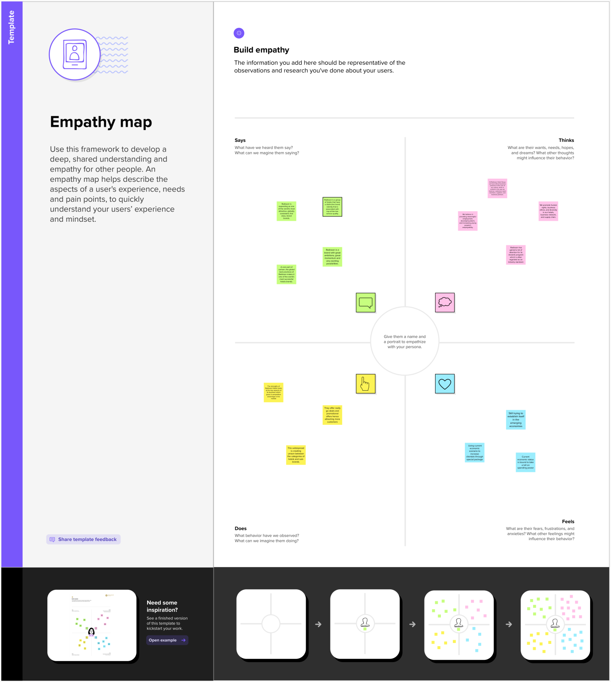

2.3 Ideation & Brainstorming Map

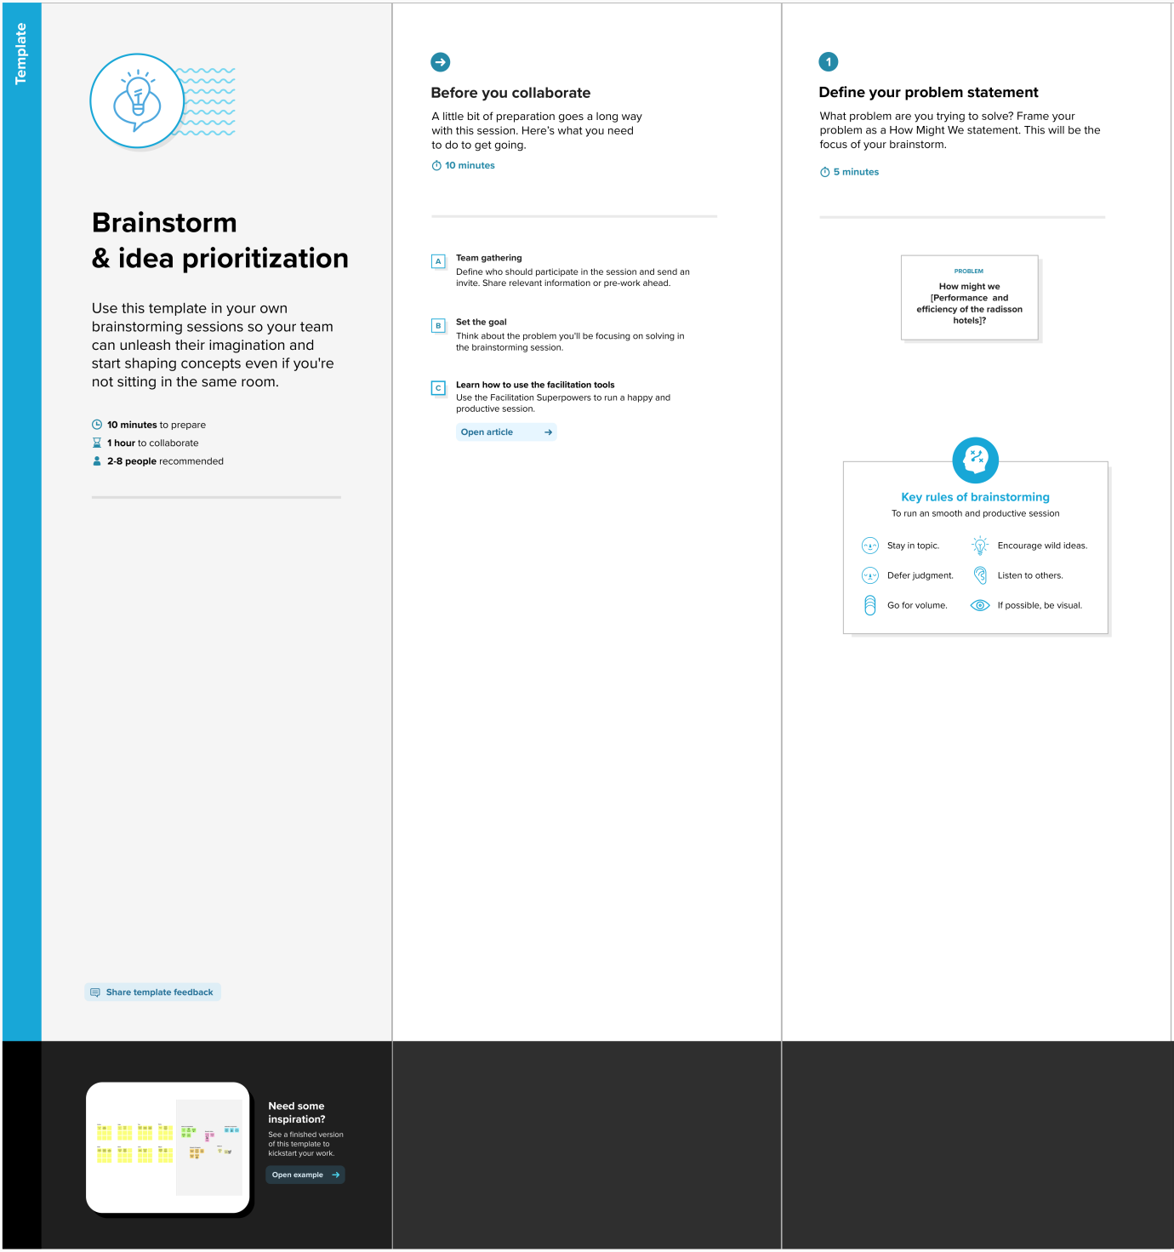

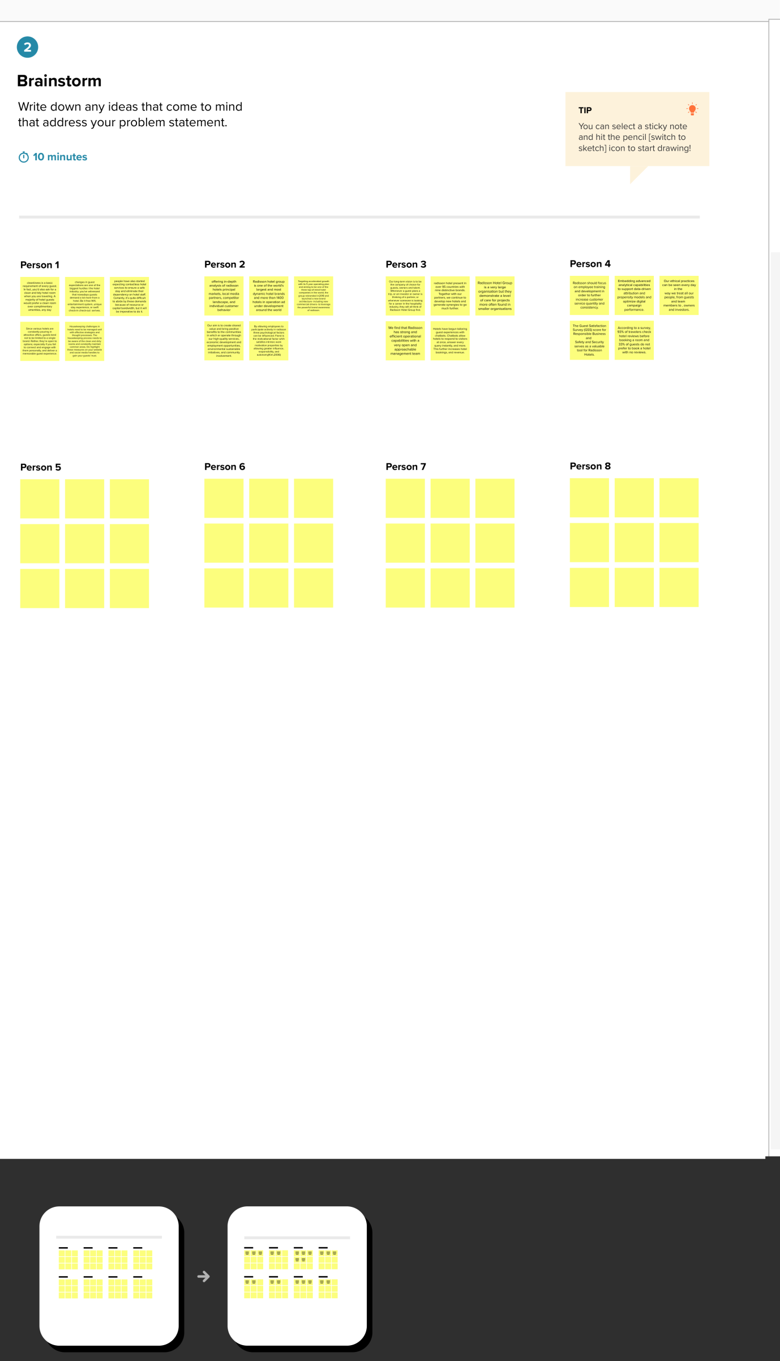

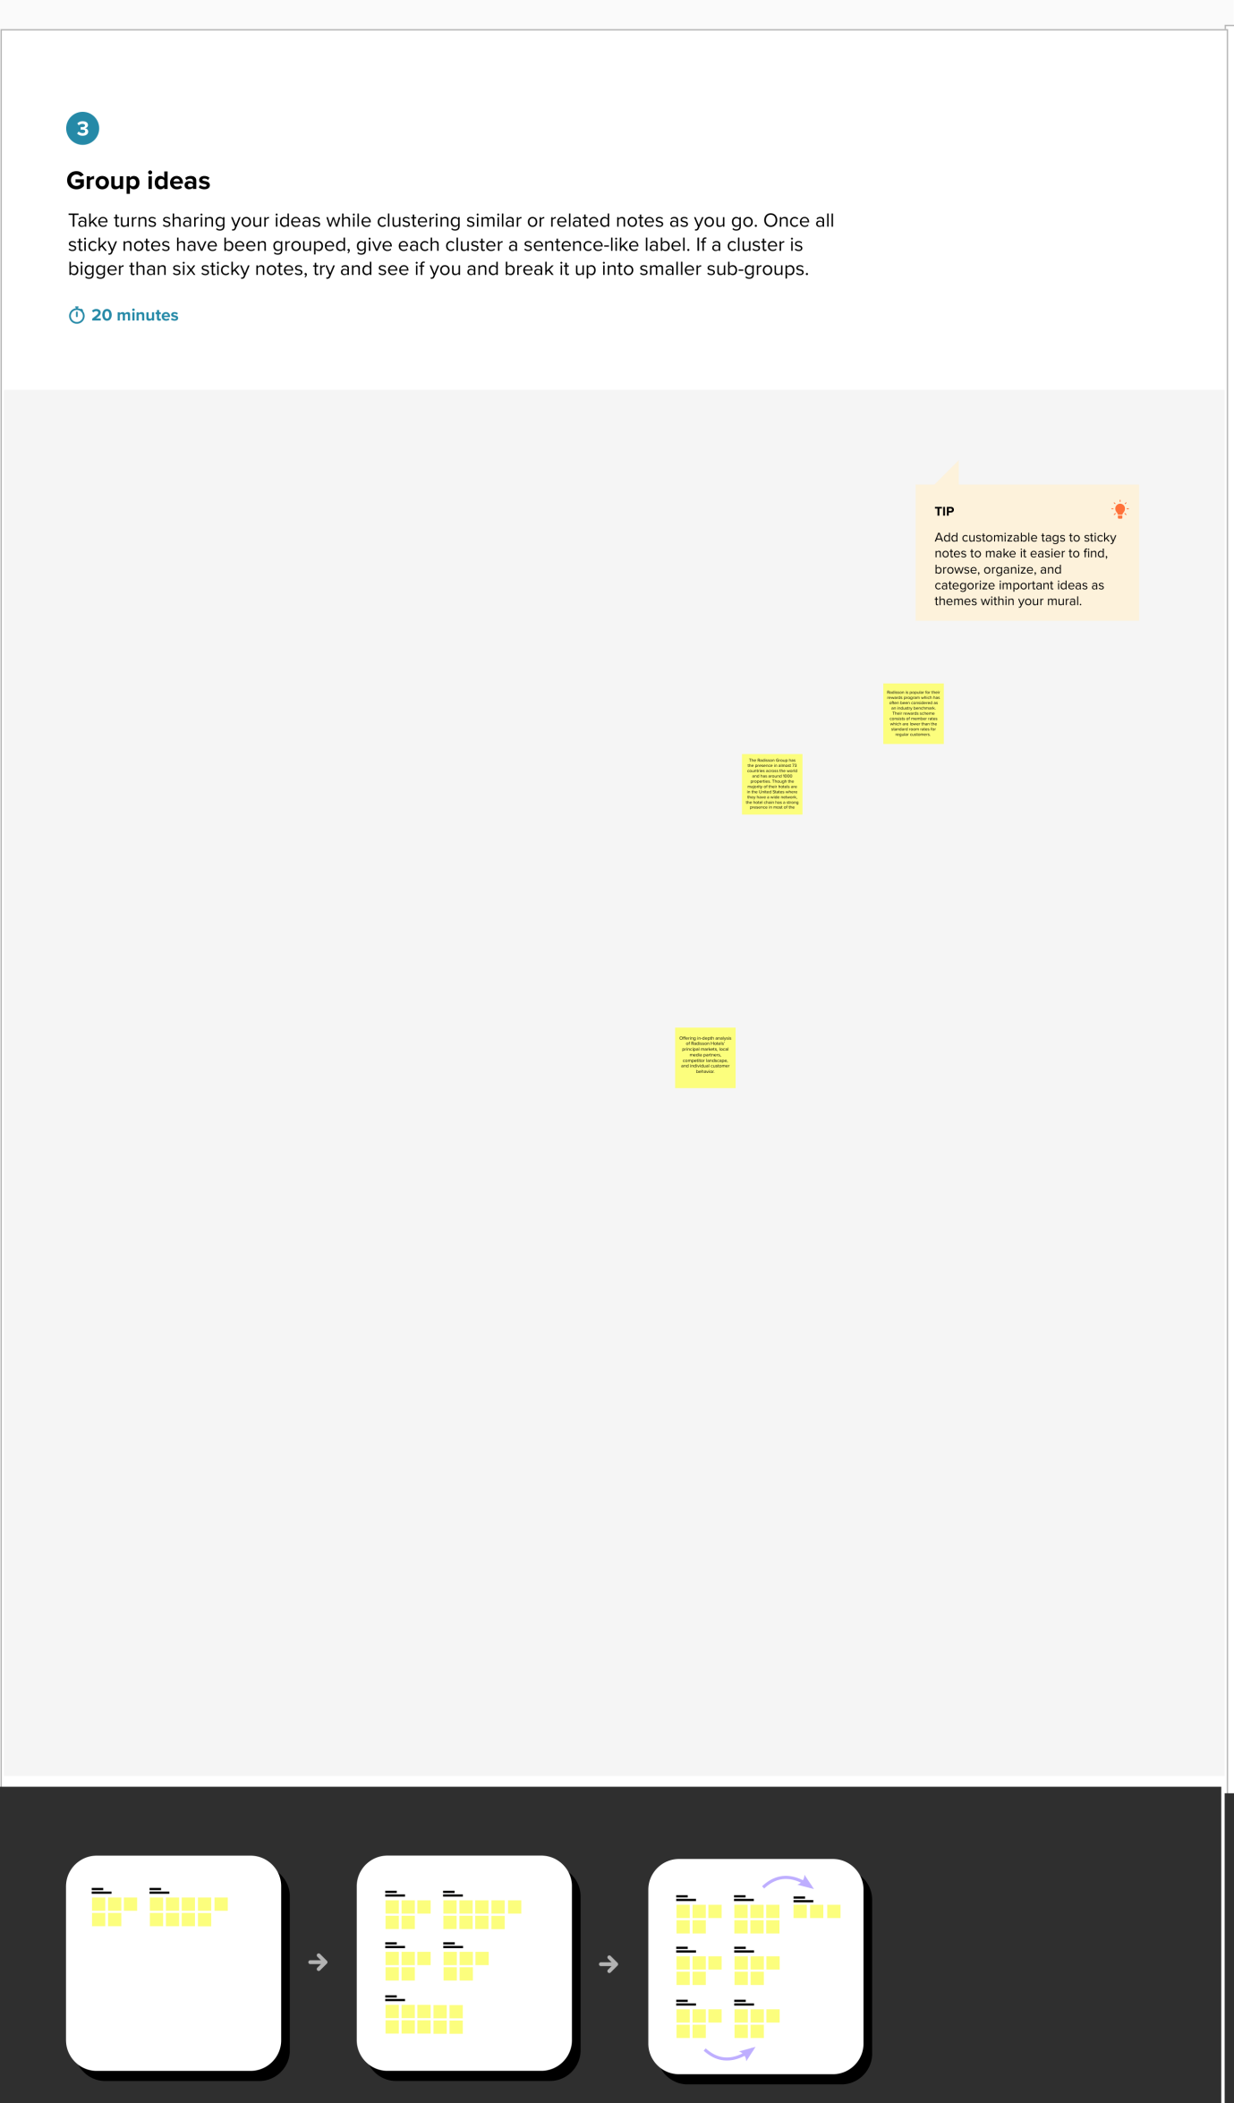

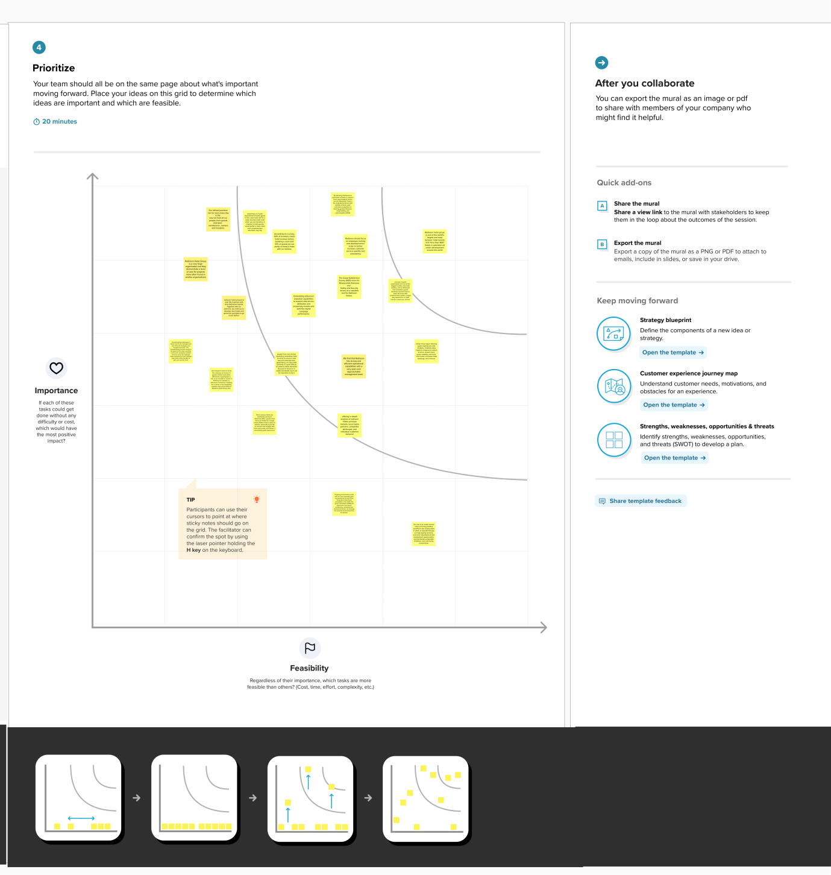

3. Result

3.1 Radisson Hospitality Analysis

A dashboard is a user interface that presents information and data in a well-organized and easily comprehensible format. They are commonly employed for real-time data monitoring and analysis and are customized to suit specific use cases.

Dashboards have various applications in industries such as business, finance, manufacturing, healthcare, and others. They aid in tracking key performance indicators (KPIs), monitoring performance metrics, and visualizing data through charts, graphs, and tables.

3.2 Radisson Analysis Story

A data story is a method of conveying information and analysis in a narrative structure, with the aim of enhancing engagement and comprehension. It usually features a concise introduction that establishes the context and background for the data, a well-organized body that systematically presents the data and analysis, and a conclusion that summarizes the main insights and their significance.

a) Mumbai has made highest number of Successful Bookings 43,455

b) Elite and Premium room classes are the top 2 highest revenue contributors

c) Other Platforms and Make your trip contributed 42% of the total checked out bookings

d) All properties have average 25% Cancellation rate and 50% Occupancy rate

4. Advantages & Disadvantages

The project is an evidence of the Data Visualization methods which the decision-making process for organizations easier, but we still have few drawbacks. Let's evaluate.

|  |  |
| --- | --- |
| ADVANTAGES | DISADVANTAGES |
| Easy data processing | Data sets must be detailed |
| Visualizations provide far better info than text or numbers | The visualizations must be accurate & reliable |
| Less creating time & even less studying time for the produced content. | The craft requires precise data sets & handling capabilities of the creator. |
| The tool has enormous capabilities in terms of data modelling | A good expertise on the tool should be achieved |

5. Applications

There are wide varieties of application for such a tool like this

● Business Intelligence

● Data Visualization

● Data Collaboration

● Data Blending

● Real-time data analysis

● Query translation into visualization

● To import large size of data

● To create no-code data queries

● To manage large size metadata

The project provides huge accessibility to opportunities where the applications are limitless using the tool, which is the fastest growing data visualization tool on the market.

6. Observation

The processing of the data has proven that, there are 3 major influencing factors that affect the variation in the Net worth. The Radisson Hotel can focus on these proceedings to strategically analysis and make key decisions regarding their organization.

* Mumbai has made highest number of Successful Bookings 43,455
* Elite and Premium room classes are the top 2 highest revenue contributors
* Other Platforms and Make your trip contributed 42% of the total checked out bookings
* All properties have average 25% Cancellation rate and 50% Occupancy rate

This analysis will help to improve the guest satisfaction and also help the Radisson Hotels management team to make better business decisions to improve market share and revenue.

7. Conclusion

In summary, the development of an analytics dashboard and story has allowed for a comprehensive analysis of Radisson Hotels' performance and efficiency, providing valuable insights for the management team. The identified key performance indicators and metrics, as well as the forecasting models, will assist in making data driven decisions to improve market share and revenue. The data story has highlighted the top influencing factors, including successful bookings, room classes, and distribution platforms, which will enable the hotels to enhance guest satisfaction and optimize their operations. Overall, the proposed solution will provide Radisson Hotels with a competitive edge in the hospitality industry.

8. Future Scope

The use of Data Analytics will yield in selection of better decisions which are good for business. People do not yet understand the potential of this field right now. It is going to be part of every industry ever thrived. The impossible will become possible, and this may well lead to an autonomous decision-making process. Data analytics is expected to radically change the way we live and do business in the future. Already today we use the analytics in our technology devices, for many decisions in our lives. Tableau is emerging as one of the hottest trends in business intelligence in 2020. The data visualization tool has been gaining popularity in companies big and small, and hence, Tableau careers are uber-in. Looking at Google trends, it seems there can be no better time than “now” to get certified in Tableau and build a career in Business Intelligence and Data Analytics. Apart from its high visualization functionality, users rate its overall performance as robust and reliable. The tool also operates fast even on big data, which makes its powerful performance an important point in the list of the advantages of Tableau. Companies in the future do not have to depend on external data professionals in order to make better decisions for their company. They can process, analyze & enhance data to learn what is good and bad for the organization. The scope is endless.

9. Appendix

9.1 Tableau Public View

Dashboard Public Link –

Story Public Link –